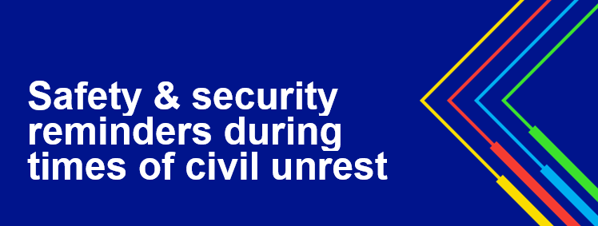

This week we saw a great deal of recent civil unrest and are asking National Grid employees to practice situational awareness. Please review the [video message](https://vimeo.com/424753940/f19ab40984) recorded by US President Badar Khan addressing the current situation. Please also be mindful of the following safety and security measures:

* Be aware of your surroundings and give yourself plenty of space to get away from danger.
* If confronted, diffuse aggression and don’t escalate.  Speak in calm tones and soft language and leave the area.
* Be careful when in large crowds or gatherings; don’t get involved in harmful or violent activity.
* Never attempt to drive through a crowd or gathering.
* Follow directions of police or emergency services.
* Follow any regulations regarding curfews.
* If living in an area where protest is occurring, be especially vigilant about your personal safety.
* Remove valuables from visibility (i.e. laptops, iPhones in vehicles).
* In line with company policies, ensure company vehicles are free of decals or decorations that may incite negative attraction or aggression
* Check home security systems, locks, and alarms.
* If you are inside a public building, try and locate two exits – one you came in and an alternate – in case you need to evacuate quickly.

Your personal safety is what is most important.  Please contact Security at [Security@nationalgrid.com](mailto:Security@nationalgrid.com) if you have questions.